E-Commerce Sales & Customer Behaviour Analysis

1. Project Background
This project analyzes Brazilian e-commerce data from the Olist dataset to understand sales performance, customer distribution, purchasing patterns, order status and product category performance.
The objective is to identify important business trends, evaluate customer behaviour, and understand which cities, states and product categories contribute to the business. The data was analyzed using Excel and PostgreSQL, with an interactive Power BI dashboard developed to present key findings and support data-driven business decisions.

2. Dataset Description
The project uses the Brazilian E-Commerce Public Dataset by Olist, which contains information about e-commerce orders, customers, products, payments and sellers.
The analysis focuses on five primary datasets:
- Customers: Customer ID, unique customer ID, city and state.
- Orders: Order ID, customer ID, order status and purchase timestamp.
- Order Items: Product ID, order ID, item price and freight value.
- Payments: Payment type, payment installments and payment value.
- Products: Product ID and product category information.
The customer dataset contains 99,441 customer records and 96,096 unique customers across 4,119 cities.
The order dataset contains 99,441 order records, covering transactions from 2016 to 2018.

3. Data Preparation and Cleaning
The datasets were inspected and prepared before performing the analysis.
- Imported the CSV datasets into PostgreSQL and Excel.
- Inspected table structures, column names and data types.
- Checked for duplicate records and missing values.
- Validated order IDs, customer IDs and product IDs.
- Connected the datasets using common identifiers such as customer_id, order_id and product_id.
- Used Excel's SUMIF function to calculate total payment values for individual orders.
- Used VLOOKUP to retrieve product categories from the Products dataset into Order Items.
- Created calculated fields to analyze order-level payment values and product revenue.
- Used Power BI relationships to connect the five datasets for interactive analysis.

4. Business Analysis in SQL and Excel
The following business questions were explored during the analysis:
 | Business Question | Finding
1 | How many customer records are available? | 99,441 customer records
2 | How many unique customers are present? | 96,096 unique customers
3 | How many cities are represented? | 4,119 cities
4 | Which cities have the highest number of customer records? | São Paulo leads with 15,540 records, followed by Rio de Janeiro with 6,882
5 | Which states have the highest number of customer records? | São Paulo leads with 41,746 records, followed by Rio de Janeiro with 12,852
6 | What is the distribution of order statuses? | Delivered: 96,478; Shipped: 1,107; Canceled: 625; Unavailable: 609
7 | What is the total order payment value? | Approximately R$16.1 million in Power BI
8 | What is the Average Order Value (AOV)? | Approximately R$160.99
9 | How do sales change over time? | Analyzed monthly and yearly payment trends from 2016 to 2018
10 | Which product categories generate the highest revenue? | Analyzed the top 10 categories using the sum of product prices
Note: Customer city and state rankings are based on customer records, not distinct customer counts. Revenue and AOV use payment values across all recorded orders.

5. Power BI Dashboard
An interactive Power BI dashboard was developed to visualize the key findings and provide an overview of e-commerce business performance.
The dashboard includes the following KPIs and visualizations:
- Total Revenue: Displays the sum of payment values.
- Total Orders: Shows the distinct count of order IDs.
- Average Order Value: Calculates average payment value per order.
- Monthly Sales Trend: Tracks payment trends over time.
- Top 10 Customer Cities: Highlights cities with the highest number of unique customers.
- Top 10 Product Categories: Identifies the highest-revenue product categories.
- Order Status Analysis: Displays the distribution of different order statuses.
- Top 10 Customer States: Compares customer distribution across states.
The dashboard helps users explore sales performance, customer distribution and order patterns through visual reports.
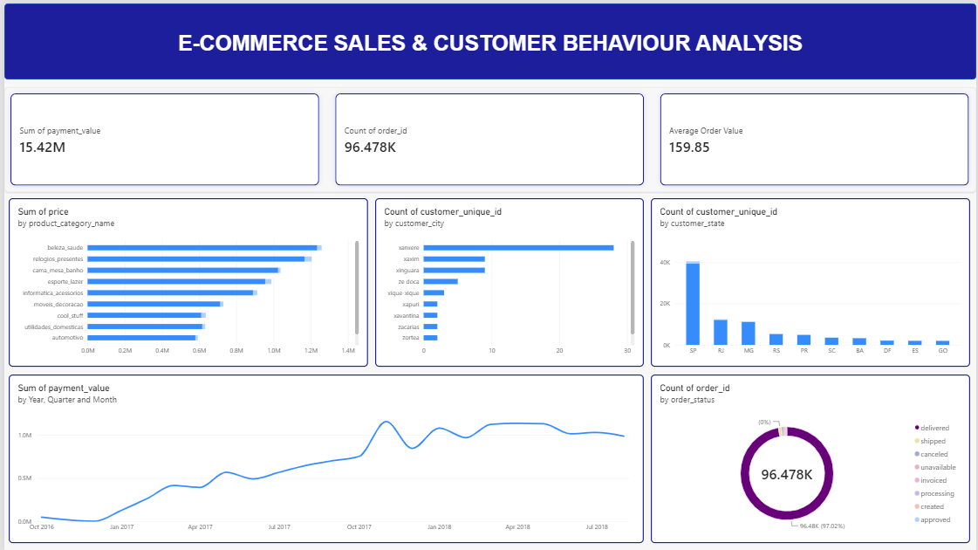

6. Key Insights
- Customer Distribution: The dataset contains 96,096 unique customers across 4,119 cities, demonstrating a wide geographical customer base.
- Geographical Concentration: São Paulo has the highest number of customer records, followed by Rio de Janeiro and Belo Horizonte.
- State Distribution: São Paulo contributes the largest share of customer records, followed by Rio de Janeiro and Minas Gerais.
- Order Fulfilment: Delivered orders account for approximately 97.02% of all recorded orders.
- Order Issues: Canceled and unavailable orders represent a relatively small share of the total order records.
- Sales Performance: Total payment value is approximately R$16.1 million, with an average order value of approximately R$160.99.
- Product Performance: Product category revenue analysis helps identify the categories contributing most to sales.
- Sales Trends: Monthly and yearly analysis provides insight into changes in business performance over time.

7. Business Recommendations
- Focus on High-Performing Locations: Prioritize marketing and customer acquisition strategies in major markets such as São Paulo and Rio de Janeiro.
- Improve Order Fulfilment: Monitor canceled and unavailable orders to identify operational issues and improve customer satisfaction.
- Optimize Product Categories: Give greater visibility to high-revenue product categories while identifying opportunities to improve weaker categories.
- Monitor Sales Trends: Use monthly sales patterns to plan inventory, promotions and marketing campaigns.
- Improve Customer Retention: Develop targeted campaigns and loyalty initiatives to encourage repeat purchases.
- Monitor Average Order Value: Introduce relevant product recommendations and bundled offers to improve average order value.

8. Conclusion
This project demonstrates how e-commerce data can be transformed into meaningful business insights using Excel, PostgreSQL and Power BI.
The analysis identified customer distribution patterns, order fulfilment performance, sales trends and product category performance. The interactive dashboard provides a consolidated view of important business metrics and can help stakeholders make informed decisions regarding marketing, product planning and operational improvements.
Through this project, practical experience was gained in data cleaning, data validation, SQL querying, data relationships, business analysis and dashboard development.

